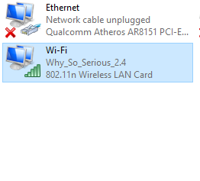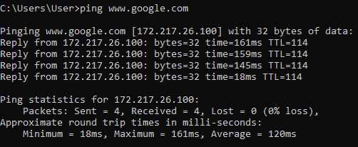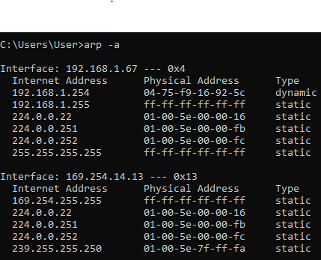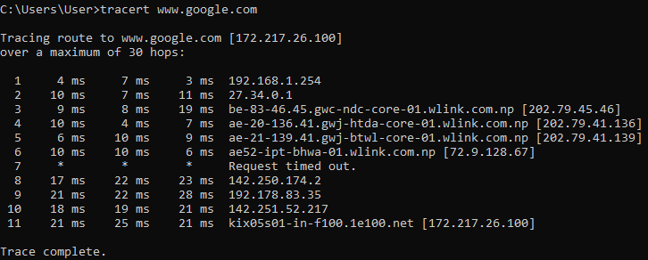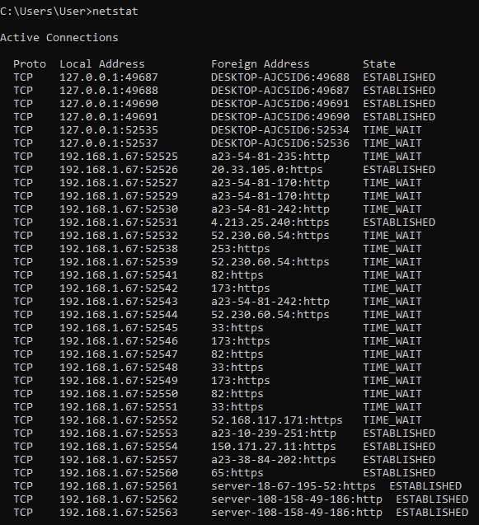hostname

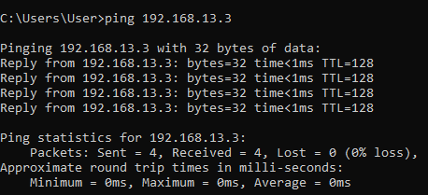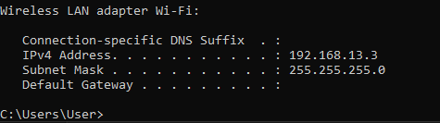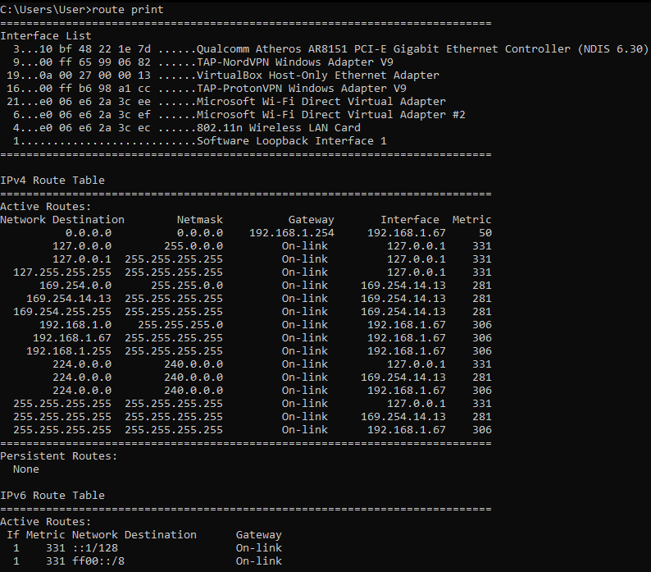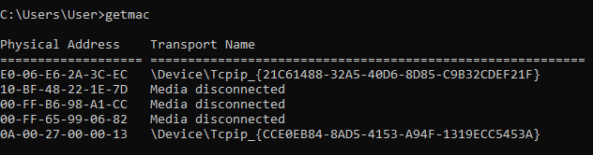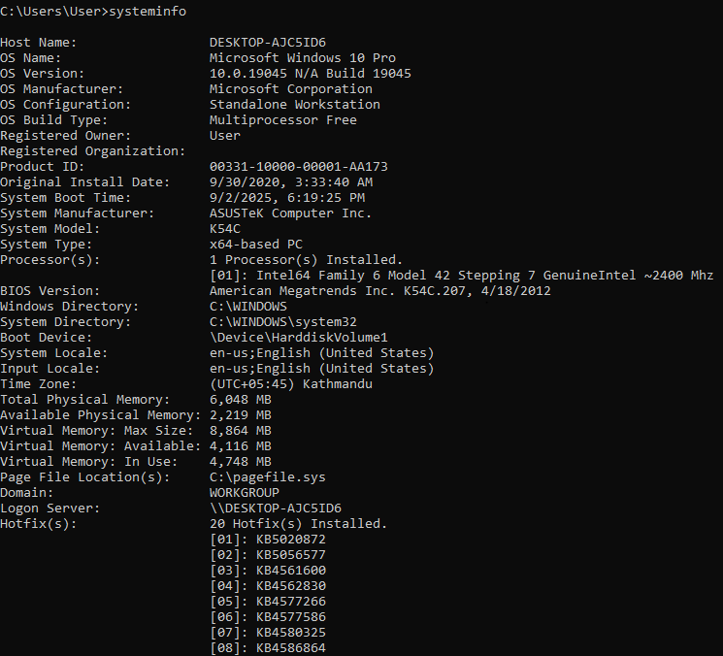

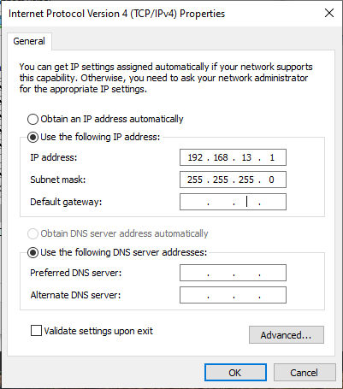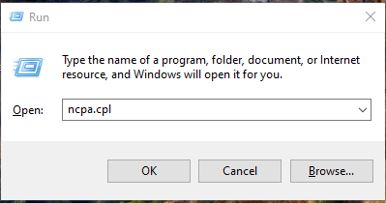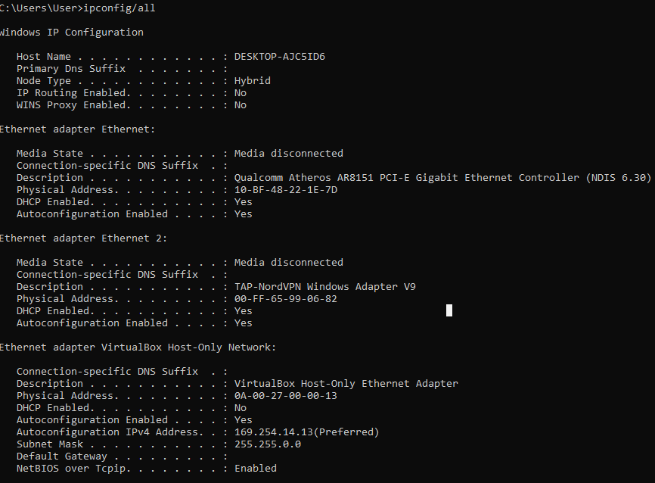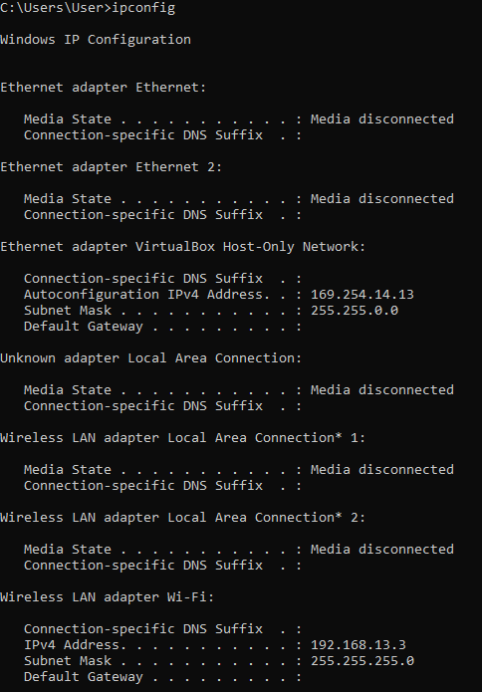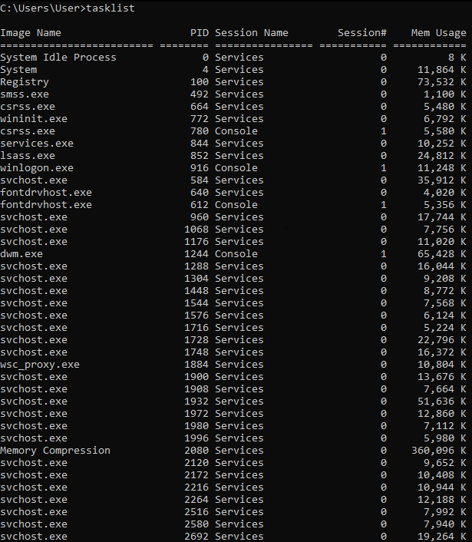

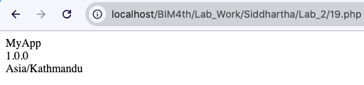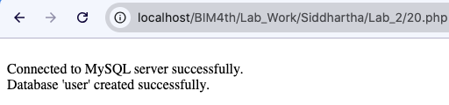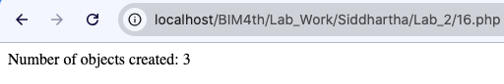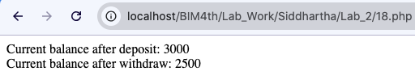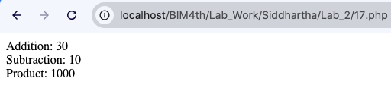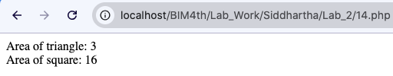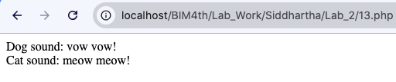

|  |  |  |  |  |
| --- | --- | --- | --- | --- |
| **S.N.** | **Program Title** | **Submission Date** | **Signature** | **Remarks** |
| 1. | Create a PHP class ‘Book’ with title, author, and price properties, and a method to display book properties. | 2025/09/04 |  |  |
| 2. | Write a PHP program to set and get private properties of a ‘Laptop’ class using getter and setter methods. |
| 3. | Create a class ‘BankAccount’ with deposit and withdraw methods and display the balance. |
| 4. | Write a PHP program to demonstrate constructor and destructor in a ‘Mobile class. |
| 5. | Create a base class ‘Person’ and a derived class ‘Student’ that adds roll number and grade. |
| 6. | Write a PHP program to show method overriding using a ‘Vehicle’ base class and a ‘Car’ subclass. |
| 7. | Create a class ‘Employee’ with salary property and extend it into a ‘Manager’ class that calculates bonus. |
| 8. | Write a PHP program to demonstrate the use of parent constructor using ‘parent::__construct()’ |
| 9. | Make a class ‘Shape’ and create subclasses ‘Circle’ and ‘Rectangle’ to calculate area. (runtime polymorphism) |
| 10. | Create interface ‘Payment’ with methods ‘pay()’ and ‘refund()’. Implement it in ‘CreditCard’ and ‘PayPal’ |
| 11. | PHP program with interface ‘Printable’ that forces Book and Magazine to implement getPrintDetails(). | 2025/09/04 |  |  |
| 12. | Create interface Logger with logInfo() and logError(). Implement them in FileLogger, DatabaseLogger. |
| 13. | Write an abstract class `Animal` with an abstract method `sound()`. Implement it in `Dog` and `Cat`. |
| 14. | Create an abstract class `Shape` with an abstract method `area()`. Implement it in `Triangle`, `Square`. |
| 15. | Make an abstract class Employee with abstract method calculateSalary() and extend it for FullTimeEmployee and PartTimeEmployee. |
| 16. | PHP program to create a `Counter` class with a static property to count how many objects are created. |
| 17. | Create a class `MathOperations` with static methods for `add()`, `subtract()`, and `multiply()`. |
| 18. | Write a PHP script to demonstrate static properties sharing values across multiple objects. |
| 19. | Make a `Configuration` class that stores settings in static properties. Display without creating an object. |
| 20. | Create a class Database with static method getConnection(). (singleton pattern idea) |